# Using the board helper

## Making a new project:

To start working with a new version of the java project do the following in eclipse

***Right click on the existing project -> Copy***.

Paste it into the package explorer (feel free to give it a new name)

Once pasted in there, open up the project and delete the files **Board**, **Vehicle**, **VehicleType**, and **Space**. **ConsoleGame** is also unnecessary so you can delete that too if you want.

This only leaves Level & GraphicsGame.

## Add BoardHelper.jar to that new project

To do this, ***right click on that new project -> Properties.***

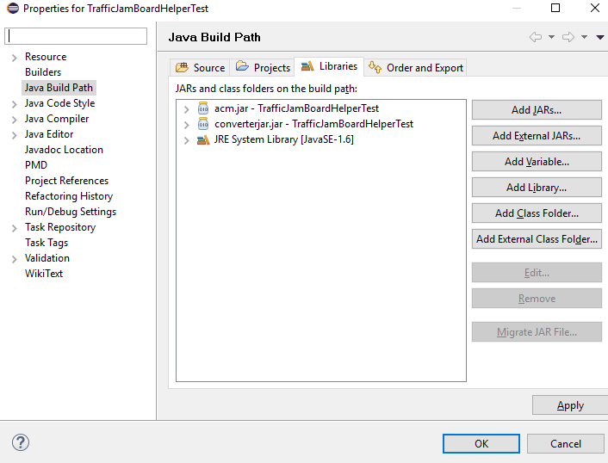

Click on ***Java Build Path***, on the left and then the ***Libraries*** tab. Then click on ***Add external jar***, locate the BoardHelper.jar file and then click OK, and click OK again to exit out of the window.

You’ll know it’s done if your **GraphicsGame** does not give you any errors. If you only have a couple of errors in Level, most likely you changed the definition of the some of the methods, so you’ll need to change those back. Look back at the word doc to see how those methods are supposed to be used.

To run the **GraphicsGame**, right click on it in the package explorer, and then say ***Run As->Java Applet***

If a window appears, then you are set and ready to go.